Lesson plan

Unit of a long term plan: Holidays |  |  |  |  | School: School – Lyceum “Daryn”
Date: |  |  |  |  | Teacher name: Aidana Mendekeyeva
CLASS: 5 |  |  |  |  | Number present: |  |  | absent:
Lesson title |  |  | Holiday activities
Learning objectives(s) that this lesson is contributing to (link to the Subject programme) |  |  | 5.S6 communicate meaning clearly at sentence level during, pair, group and whole class exchanges  5.R2 understand with little support specific information and detail in short, simple texts on a limited range of general and curricular topics  5.UE10 use present continuous forms with present and future meaning on a limited range of familiar general and curricular topics
Lesson objectives |  |  | ALL LWBAT:  - answer the true or false sentence  - discuss their answers in the whole class  - identify the difference between present simple and present continuous  - describe the picture with support  MOST LWBAT:  - answer the questions according to the text with little support  - make up sentences using present continuous form with few errors  SOME LWBAT:  - describe his / her holiday using present continuous form according to the example with no errors
Assessment criteria |  |  | Identify details in a text with little support  Apply present continuous form  Provide a description of people, places and objects
Values links |  |  | Travelling, family.
Cross-curricular links |  |  | Nature science
Previous learning |  |  | Grammar: Present Continuous Tense  Vocabulary: travel, swim, eat, drink, sunbathe, sunglasses
Plan
Planned timings | Planned activities |  |  |  |  |  | Resources
Start  3 minutes | Lead – in. Mind-map  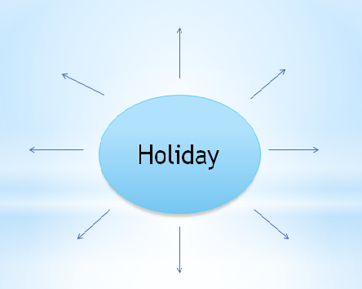  The learners say the associations with “Holiday activities” and they do a mind-map on the whiteboard.  Formative Assessment technique: graphic organizer |  |  |  |  |  | Whiteboard
Middle  5 min  5 min  7 min  15 min | Guided discovery task  Two sentences are written on the whiteboard:  “I swim” and “I’m swimming now”. The learners identify the difference between them and try to translate. They notice the word “now” and that it is the action that happens at the time of speaking. Then the learners write the rule with examples. The teacher guides the learners demonstrating time-line as scaffolding.  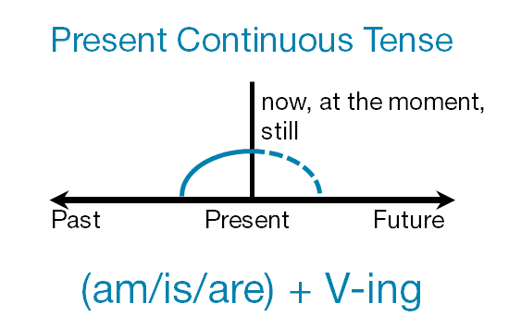  Presenting a vocabulary using visual aids  The learners look at the pictures (swim, eat, drink, sunbathe, sunglasses) and repeat the words after the teacher.  Drilling: choral repetition  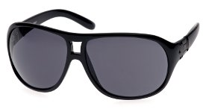    The new words are written on the whiteboard, the learners should write them down to their vocabularies.  Pre-reading:  “Keep talking” activity  The learners make a circle, look at the picture and say one sentence to make a story using present continuous tense.  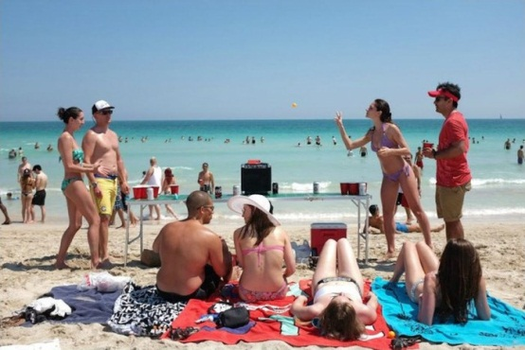  FA technique: time-lines, observations, delayed correction  “Think – pair – share” activity  The learners are given the text with the task and divided into 3 groups. Firstly, they read individually and underline new words and verbs in present continuous tense. All learners do the True / False task. Most learners answer the questions after the text. Some learners make up their own examples on the topic “Holiday activities”.  Then they answer the questions after the text and then they discuss their answers with their classmates.  FA technique: think-pair-share  Differentiation by task and support  Differentiation by task. The text with the task is given according to their abilities.  Less able learners do the true and false task.  More able learners answer the questions according to the text and bring their own example.  Differentiation by support.  Less able learners are provided with the translation of some new vocabulary.  More able learners will be challenged by assessing their peers.  While – reading:  Holiday activities  Hi! We’re on holiday and we’re travelling on planet Earth. At the moment we are staying in Britain. I’m practicing my English a lot. The temperature is -5 C, so we’re not sunbathing on the beach! I’m not wearing my sunglasses. At the moment we are having lunch. In this café, people are having animals and plants. They say this is “meat” and “salad”. It’s horrible! Some people are playing a game with an egg. Very strange! We are having a good time.  Post – reading:  True / False:  1. They’re not travelling on planet Jupiter.  2. They’re staying in Brazil.  3. They’re sunbathing.  4. People are having animals.  5. They enjoyed their time.  Questions:  1. Where are they travelling?  2. Are they sunbathing?  3. What are people having for lunch?  4. What are others doing?  5. Are they having a good time?  Story:  The learners’ own answers.  FA technique: peer and self-correction  Descriptor:  A learner:  - reads the text  - answers the questions using the information from the text  - describes his / her holidays in 5 sentences using present continuous  FA technique: questioning |  |  |  |  |  | Whiteboard  Pictures  “Activities for the language classroom” (ex. 9.4, p. 28)  “Active Teaching and Learning” (NIS), p. 46  Text: “Holiday activities”  (English Plus, SB: ex. 5, p. 85)
End  5 min | One Minute Paper  An easy way to build learner reflection into the teacher’s daily classroom routine. The traditional version of the “one minute paper” asks students two questions.  - What is the most important thing you learned during class today?  -What question (s) do you have? |  |  |  |  |  | “20 Feedback hacks for English Teachers” by Ann Lindsay, p. 4.
Additional information
Differentiation – how do you plan to give more support? How do you plan to challenge the more able learners? |  |  |  | Assessment – how are you planning to check learners’ learning? |  | Health and safety check
Differentiation by task. The text with the task is given according to their abilities.  Less able learners do the true and false task.  More able learners answer the questions according to the text and bring their own example.  Differentiation by support.  Less able learners are provided with the translation of some new vocabulary.  More able learners will be challenged by assessing their peers.  Multiple Intelligence by H. Gardner:  Interpersonal - when the learners do post-reading tasks and discuss their answers in the whole class.  Visual / Spatial – when the learners do “Keep talking” activity and describe the picture and when the teacher presents a new vocabulary. |  |  |  | Time lines (error correction)  Observations (error correction)  Think – pair - share  Peer and self – correction (error correction)  Delayed correction (error correction)  Questioning ( convergent, probing) |  | Circle time activity
Reflection

Were the lesson objectives/learning objectives realistic?
Did all the learners achieve the lesson objectives/ learning objectives? If not, why?
Did my planned differentiation work well?
Did I stick to timings?
What changes did I make from my plan and why?

Summary evaluation

What two things went really well (consider both teaching and learning)?

1:

2:

What two things would have improved the lesson (consider both teaching and learning)?

1:

2:

What have I learned from this lesson about the class or individuals that will inform my next lesson?

