Short term plan

Lesson plan

Unit of a long term plan: Unit 3. Our World |  |  |  | School: 8
Date: |  |  |  | Teacher name: Alexandra Ilina
CLASS: 9th Grade |  |  |  | Number present: | absent:
Lesson title |  | CLIL Ecology: solving an ecological problem
Learning objectives(s) that this lesson is contributing to (link to the Subject programme) |  | 9.1.6.1 organise and present information clearly to others;  9.3.7.1 use appropriate subject-specific vocabulary and syntax to talk about an increased range of general and curricular topics;  9.4.5.1 deduce meaning from context in extended texts on a range of familiar general and curricular topics;  9.4.6.1 recognise the attitude or opinion of the writer in extended texts on a range of familiar general and curricular topics;
Lesson objectives |  | By the end of the lesson all students will be able to:  - note advantages or disadvantages of nuclear, wind and hydroelectric power using the text and video  - select the right points from the text using key words during skimming the text with minimum support  - predict the meaning of unknown words from the context in completing the reading task with maximum 2 mistakes.  By the end of the lesson most students will be able to:  - consider different types of energy power and their benefits and drawbacks with minimum support;  - pick up the main points from the text according to the task about nuclear, wind and hydroelectric e-sources;  - prove the choice of the most appropriate power source with a help of the given texts with minimum support, using L1 if it is needed.  By the end of the lesson some students will be able to:  - indicate an opinion about the up-to-date energy sources building extended sentences using vocabulary from the texts “Nuclear, wind and hydroelectric power” with minimum support;  - complete the reading tasks with 90% of accuracy  - carry out their own study through reading extra information and ecology challenges from the site https://www.gov.uk/guidance/2050-pathways-analysis given at the lesson
Assessment criteria |  | - Center on understanding the text about a car that runs on air.  - Argue the topic with peers, agree or disagree on it and make conclusions to fulfill the task  - Use topic related words with correct spelling control  - Deduce an appropriate information during scanning the text and complete the task in the correct way
Values links |  | Educate to respect the world we live in, keep power and energy
Cross-curricular links |  | Environmental studies, ICT, Physics: Engineering
Previous learning |  | Environmental problems/ Energy sources sustainability/Responsibility to our planet (English Plus 9, Students book, p. 32,34,41)  Study key phrases: Opinion (English Plus 9, Students’ book p.39)
Plan
Planned timings | Planned activities |  |  |  |  | Resources
Start  (10 min.) | Lead-in  Brainstorming “Being GREEN”  Whole group and pair discussion (3-4 min.)  Students look at the poster “I am GREEN”  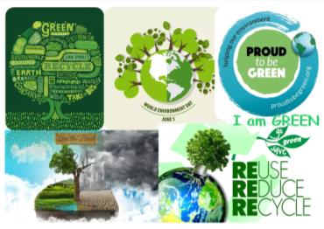  They are elicited to share the ideas of ‘being green’  Possible answers: to take care of nature, save and not to damage the world around us, be more conscious of environment, ect.  Then students discuss in pairs what they think can be done to be ‘more green’  Possible answers: recycle, reduce and reuse things, use public transport instead of cars, use environmentally friendly energy powers, etc.  Error correction: “Ignoring slips or gesture correction”  Green-Word-Tree  Students work in pairs (6-7 min.)  Students look at the GWT below and decide which words they already know and which are new.  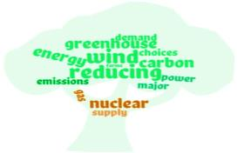  “GREEN-Circle-Organizer”  After that student are asked to match words from “GREEN-Circle-Organizer” to make new phrases.  First, students compare their ideas in pairs.  Then students give the possible answers to each point in the classroom. Classmates discuss the answers, check and correct each other (“Peer correction”, teacher uses “Finger correction” to pay students’ attention on the key points of the task).  Keys:  major choices energy supply energy demand carbon emissions nuclear power greenhouse gas wind power reducing emissions |  |  |  |  | POSTER “I am Green” is made with a help of pictures taken from:  yandex.kz, pictures of inquiry ‘to be green’  Worksheet 2  Task 1  Green-Word-Tree is made on the side:  https://www.visme.co/tree-diagram-maker/  Worksheet 2  Task 2  Vocabulary is taken from the adapted texts “The energy challenge”:  http://www.decc.gov.uk/en/content/cms/tackling/2050/2050.aspx
Middle  (20 min.) | Pre-reading stage (5 min.)  To monitor vocabulary understanding students put the given phrases into the text below. They work in groups.  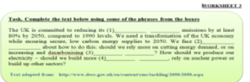  Students give the possible answers to each point in the classroom. Here teacher doesn’t correct them, just gives opportunity to name out their predictions (“Ignoring slips”). Then they share the answers in class, check and correct each other (“Peer correction”)  Keys:  (1)greenhouse gas, (2)major choices, (3)energy supply, (4)wind farms.  Jigsaw-Reading stage (15 min.)  *First reading (overall understanding)  Students are divided into three groups and each group has different text (Nuclear Power, Wind Power, Hydroelectric Power). By the first reading they work together to highlight the main points from their text.  - What is it? How does it work?  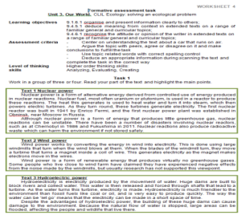  Feedback: Students discuss their answers in groups before eliciting their ideas in the class. They and teacher use “Finger correction” indicate the mistakes/slips.  *Second reading (detailed understanding)  By the second reading students fill in the table using the given information from the texts. After regrouping present the topic to other groupmates to fulfill the task.  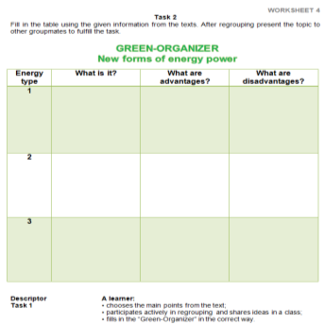  Feedback: When they have completed the task in 5-7 min., teacher asks them to move from one desk to another and check the answer. This will give them the opportunity to refer back to the text and perhaps correct their own mistakes. They have no more than 2-3 minutes to work with 1 worksheet.  Error correction is supported by peers/classmates.  Keys (possible answers, but students can rewrite or paraphrase the sentences):  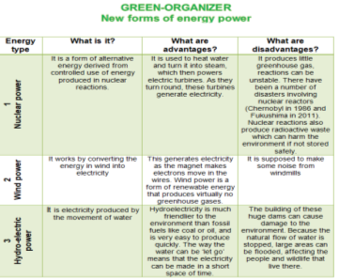  Post-reading stage (Follow-up) – 5 min.  Students back to their groups and compare the tables or open up the debate to the whole class.  Feedback: Students make brief summary based on what they have read and told each other about alternative energy sources.  Error correction is supported by peers/classmates, also used “Finger correction or ignoring slips” |  |  |  |  | Worksheet 3  Text adapted from: http://www.decc.gov.uk/en/content/cms/tackling/2050/2050.aspx  Worksheet 4  Jigsaw Reading  Worksheet 4  Formative assessment task  Highlighters  Group working strategy  Task 1  Task 2
End  (10 min.) | Feedback/Reflection (10 min.)  First students watch the video “The energy challenge”  Students work alone, outline their hand and number the fingers 1-5. To each number they have to write notes according to the given question.  GREEN MAKES FIVE 1 Name 2 What source of energy power do you choose? Why? 3 What are its’ advantages/ disadvantages? 4 Have you ever seen such type of energy power somewhere? If not, would you like to see it? 5 What was the easiest/hardest part of your work today?  Students join into groups and explicit their ideas to each other. Teacher monitors and coordinates the process of Feedback. Error correction technique is based on ignoring errors that are above the students’ language level.  - Hometask: In groups create “A community project”  Criteria:  Present a short description and poster of your organization. Give details of the following:  - design a slogan  - Who and what will your organization help?  - What is your mission statement?  - How do people join in? Invite people to come and see your organization. |  |  |  |  | Worksheet 5  Feedback and Reflection  The video: “The energy challenge”  https://youtu.be/deT0_ERH7ls  English Plus 9, Students’ book, p.43 ex.1-3
Additional information
Differentiation – how do you plan to give more support? How do you plan to challenge the more able learners? |  |  | Assessment – how are you planning to check learners’ learning? |  |  | Health and safety check
Differentiation by support:  Scaffolding techniques such as Activation prior knowledge, Pairing/Grouping Strategies, GREEN-Table Organizer, Using visuals & Imaginary: “POSTER – I am GREEN”, video: “The energy challenge”: https://youtu.be/deT0_ERH7ls  Autonomous learning for stronger students (active learning): students can study the site http://my2050.decc.gov.uk/ in their own time This website allows them to experiment with different energy and lifestyle choices to make a plan to reduce greenhouse gas emissions. It provides the user with a visual image of what life will be like at home, at work and generally, based on the choices they make.  Differentiation by outcome (hometask):  - In groups create “A community project”  Criteria:  Present a short description and poster of your organization. Give details of the following:  - Design a slogan  - Who and what will your organization help?  - What is your mission statement?  - How do people join in? Invite people to come and see your organization.  Learning styles:  Lead-in: Brainstorming and giving predictions and ideas(visual, group, impulsive)  Pre-reading: Guess the information by word combinations (visual, group, impulsive, individual)  Reading  First: Check your predictions on the main point from the text (individual, visual, reflective)  Second: GREEN-Table Organizer (individual, group, bodily-kinesthetic, reflective, auditory)  Post-reading  Compare and prove(auditory, group, reflective, impulsive, visual)  Feedback/Reflection  “GREEN MAKES FIVE” (individual, group, reflective, impulsive, visual)  Multiple intelligences:  Lead-in: spatial-visual, linguistic, naturalistic  Pre-reading: spatial-visual, interpersonal  Reading  First: intrapersonal, spatial-visual  Second: spatial-visual, naturalistic, interpersonal  Post-reading: interpersonal, bodily-kinesthetic, linguistic  Feedback/Reflection: intrapersonal, spatial-visual, interpersonal, bodily-kinesthetic |  |  | Brainstorming: discussion  "Being GREEN", “GREEN-Circle-Organizer”  Error correction techniques: “Peer and self-correction”, “Ignoring errors”, “Finger correction”  Fill in the gaps to check students’ vocabulary (pre-reading stage)  Formative assessment task: “GREEN– Table Organizer”  Feedback/Reflection “GREEN MAKES FIVE” |  |  | “Gigsaw Reading”:  Moving from one desk to another to fulfill the task (“GREEN-Table Organizer” worksheet 4)  “Find a classmate to say”: students walk around the class and find a peer to share his/her ideas to (Feedback “GREEN MAKES FIVE”)
Reflection  Were the lesson objectives/learning objectives realistic?  Did all the learners achieve the lesson objectives/ learning objectives? If not, why?  Did my planned differentiation work well?  Did I stick to timings?  What changes did I make from my plan and why? |  |  | Use the space below to reflect on your lesson. Answer the most relevant questions from the box on the left about your lesson.
Summary evaluation

What two things went really well (consider both teaching and learning)?

1:

2:

What two things would have improved the lesson (consider both teaching and learning)?

1:

2:

What have I learned from this lesson about the class or individuals that will inform my next lesson?

