Unit 3: Our countryside |  |  |  | School: Minkeser secondary school
Date: |  |  |  | Teacher’s name: Chereshko T.V.
Class: 6 |  |  |  | pr. | absent:
Lesson title: |  | CLIL. Geography and natural science: Animals
Learning objective(s) that this lesson is contributing to |  | 6.C10 use talk or writing as a means of reflecting on and exploring a range of perspectives on the world  6.S7 use appropriate subject-specific vocabulary and syntax to talk about a range of general topics, and some curricular topics  6.S8 recount basic stories and events on a range of general and curricular topics ( describe vertebrates)  6.R1 understand the main points in texts on a growing range of unfamiliar general and curricular topics, including some extended texts
Lesson objectives |  | All learners will be able to:  name the pictures using the target vocabulary (animals, body parts, animal groups)  put the animals into groups  answer the simple general questions about animals
Most learners will be able to:
answer the simple special questions using the target vocabulary (animals, body parts, animal groups)
put the animals into groups, find the characteristics for groups with some mistakes and check their work
ask and answer the simple general questions about animals
Some learners will be able to:
answer the growing range of special questions using the target vocabulary (animals, body parts, animal groups)
classify animals correctly, find the characteristics for groups without mistakes and check their work
ask and answer more complex special questions about animals, guess the animals
Assessment criteria |  | Ss- name the animals and their body parts  - classify the animals into groups correctly (6 groups)  - find 2 characteristics for animals groups  - ask 4 or more questions about an animal  - answer 4 or more questions and guess the animals
Value links |  | Nature saving
Cross curricular links |  | biology, ecology
Previous learning |  | names of animals, some animal body parts
Plan
Planned timings | Planned timings |  |  |  |  | Resources
Start  1  3min  (I)  3 min  (P) | Organizational moment. Brief conversation with the pupils on duty. Regrouping students into pairs.  Lead-in  Presentation of the lesson title and actualization of the prior knowledge. Teacher presents the lesson title:  “Today we are talking about animals. Please name the animals if you know them”- Ss name the animals.  “Well done, you`ve already know a lot of animals, now do you remember the animals` body parts?”- Ss name animals` parts of the body (remembering level)  Students get the assessment criteria tables and put stickers or points for each correct answer.  “Very good, you know a lot about animals. Now I give you small cards with different animals. The task is to divide them into groups. You should define the number and the types of the groups by yourselves”  At the end of the time teacher asks:  “How many groups have you got?” (6 groups)  “What animals have you put together?” (pig and bear, butterfly and bee, etc)  “Do you know the titles of the groups?” and elicit the answers. There is no estimation at the stage the task is done as a brainstorming.  Teacher presents the lesson objectives, explains students what they would be able to do by the end of this lesson-  You will be able to talk about the different animal groups |  |  |  |  | flashcards with familiar animals and animal body parts  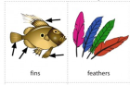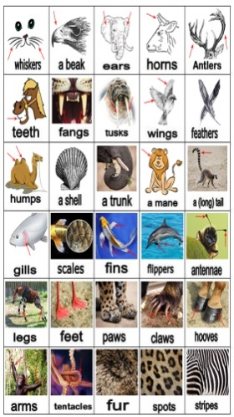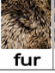  handouts  pictures from oakdome.come  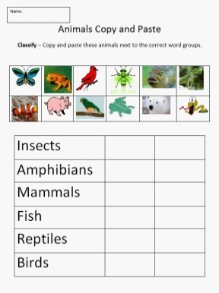
Middle (27 min)  (8 min)  (P)  (2 min)  (C)  (10 min)  (G)  (10 min)  (G-C) | Classifying the animals  Now you get the tables with the titles of animals groups. Put the picture into the table, then watch the video and check your answers. (understanding and applying)  Students work in pairs, put the pictures into the table, watch the video and check their work (self-assessment)  Teaching the words vertebrate, mammal, reptile, amphibian  (Using mother tongue if needed)  Energizer (The Incy- Wincy spider) and regrouping students into 6 groups: mammals, reptiles, amphibians, fish, insects, birds.  Reading and matching  Groups get the instruction: Find the characteristics for your group in the list. (handouts)  (Scaffolding: Students check the meaning of the words in their dictionaries) (Analyzing)  The answer key is on the board, groups check and evaluate the other group`s work. (peer-assessment)  Answers:  Birds: 3,9 Fish: 6,10 Amphibians: 1,7  Insects: 11, 12 Mammals: 2, 5 Reptiles: 4,8  Guess the animal. Student from the first group choose the animal and writes its name on the card. Student from other groups ask questions from the list and their own questions about the animal and guess what it is.  - Does it feed its babies milk?  (Yes: It`s a mammal. No: go to #2)  - Has it got feathers and wings?  (Yes: it`s a bird. No: go to #3)  - Has it got fins?  (Yes: it`s a fish. No: go to #4)  - Has it got scales?  (Yes: it`s a reptile. No: It`s an amphibian) |  |  |  |  | handouts  tables from oakdome.come  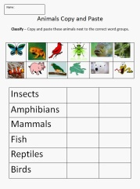https://youtu.be/dCm5CcQhU-c  Handouts: Different classes in the animal kingdom  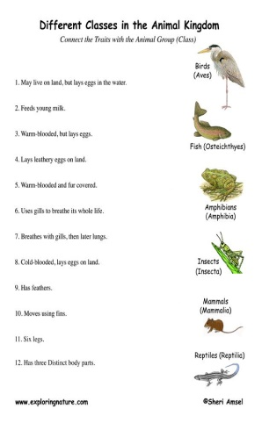  English Plus  Ex.3, 4 p.44
End  3 | At the end of the lesson, learners reflect on their learning:  Students count their points and decide if they are reached the aim of the lesson. Teacher tells about the lesson objectives and elicit the answer: We can talk about different animal groups |  |  |  |  | H/t Ex.1, p.44 (English Plus) and presentation about any animal group.
DIFFERENTIATION – how do you plan to give more support? How do you plan to challenge the more able learners? |  |  | ASSESSMENT – how are you planning to check learners’ learning? |  |  | Health and safety rules
For less – able students: support them while speaking and reading. (dictionaries, less difficult questions addressed to them) Strong students – more complicated questions |  |  | Monitoring learners’ activities, focusing on their speaking and writing, jotting down typical mistakes or errors and discussing and working on correcting them.  Points for tasks in the form of cards, discussing the assessment criteria. |  |  | Provide some physical exercises for learners (Energizer)

 | Assessment criteria | maximum points | my points
1 | I can name the animals and their body parts | -
2 | I can classify the animals into groups correctly | 12
3 | I can find characteristics for animals groups | 2
4 | I can ask questions about an animal | 4
5 | I can answer the questions and guess the animals | 4

Recourses
- Animals copy and paste task
oakdome.come https://i.pinimg.com/originals/ab/9a/06/ab9a06247c23a9cd4f0df7cf82c79dd4.gif
- Classifying animals video
YouTube https://youtu.be/dCm5CcQhU-c

- Animals body parts pictures
https://c1.staticflickr.com/5/4198/34581157230_3fbc2bb2d5_o.jpg
- Different classes in the animal kingdom
Exploring nature.com
https://i.pinimg.com/736x/96/56/95/96569512ec358ec0d20c0f0aa7a8ecac--science-activities-science-ideas.jpg
- English Plus for Kazakhstan grade 6, Express publishing 2018

