Short term plan
Lesson plan

Unit of a long term plan:  Values in Myths and Legend. |  |  | School: «Vodoprovodnaya high school», North Kazakhstan region
Date: 08.10.2019 |  |  | Teacher name: Anastassiya Spiridovich
CLASS: 4th Grade |  |  | Number present: 4 |  | absent:0
Lesson title |  | Traditional stories. Birthday party
Learning objectives(s) that this lesson is contributing to (link to the Subject programme) |  | 4.2.3.1 give short, basic description of people and objects, begin to describe past experiences on an increasing range of general and some curricular topics;  4.3.5.1 understand the main points of short simple texts on a growing range general and some curricular topics by using contextual clues; 4  4.4.7.1 spell most familiar high-frequency words accurately when writing independently;
Lesson objectives |  | By the end of the lesson all students will be able to:  - name the key points to write birthday invitation  - write in short Birthday invitation with the support of sample-text  - use “Writing worksheet” to invite classmates to Birthday Party  By the end of the lesson most students will be able to:  - discuss and circle top tips to write the birthday invitation  - use top tips to write their personal birthday invitation card  By the end of the lesson some students will be able to:  - formulate sentences in the process on inviting classmates to the Birthday Party
Assessment criteria |  | Name and point key-words to write an invitation.  Fill in the gaps in the text “My birthday party”.  Write your own invitation to the birthday party.
Values links |  | Traditional and habits
Cross-curricular links |  | PE, Handwriting
Previous learning |  | Holidays in KZ and GB, Vocabulary “Holidays”
Plan
Planned timings | Planned activities |  |  |  |  | Resources
Start  (10 min.) | Lead-in  “Auction activity”  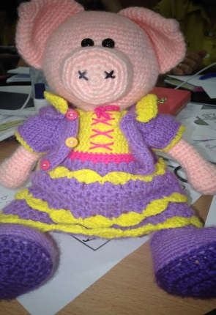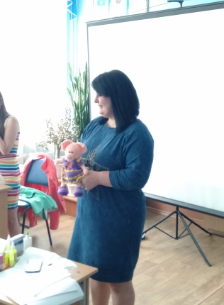  My Birthday invitation  “Hello, guys. I’m here not along today. This is my friend. Her name is Piggy Ginny. “Piggy Jenny” has the birthday party today. Let's congratulate her happy birthday.”  The students watch the video. In the video, funny cartoons sing the song "Happy birthday to you."  Students sing the song “Happy birthday” to Piggy Ginny.  After watching the video, students are given out worksheets.  “Piggy Ginny brought you a game. Let’s play. Piggy Ginny will help you.”  Realia: Piggy Ginny.  Students work in groups/pairs. They are going to write a birthday invitation.  In groups ST sum up the information/words they need to write the birthday invitation.  Worksheet 1. What information do you need to write a birthday invitation?  Birthday Invitation  Worksheet 1  Children work, a teacher walks in groups with a toy in hands, supervises the work of children. Asks questions, prompts, eliminates gaps in understanding.  At the end of the work and receiving the prize, the children say goodbye to Ginny Piggy.  Feedback: Students name word by word in the whole-class, don’t repeat the answer. The group, which has the most words, wins. Alternatively, you can award the winning team sweet prizes (for example, candies).  e.g.: I need “party/ date/ street/time/ telephone/”  Error correction: teacher monitors, doesn’t tell them answers, just control the “Auction activity”.  Differentiation by support. |  |  |  |  | Blackboard  Piggy Ginny  https://www.youtube.com/watch?v=GiAoB4xDvvA  Worksheet 1  Pencils  Pair/Group work
Middle  (25 min.) | Pre-writing stage (5 min.)  - Read and circle  Read the birthday party invitation and circle the examples of the top tips.  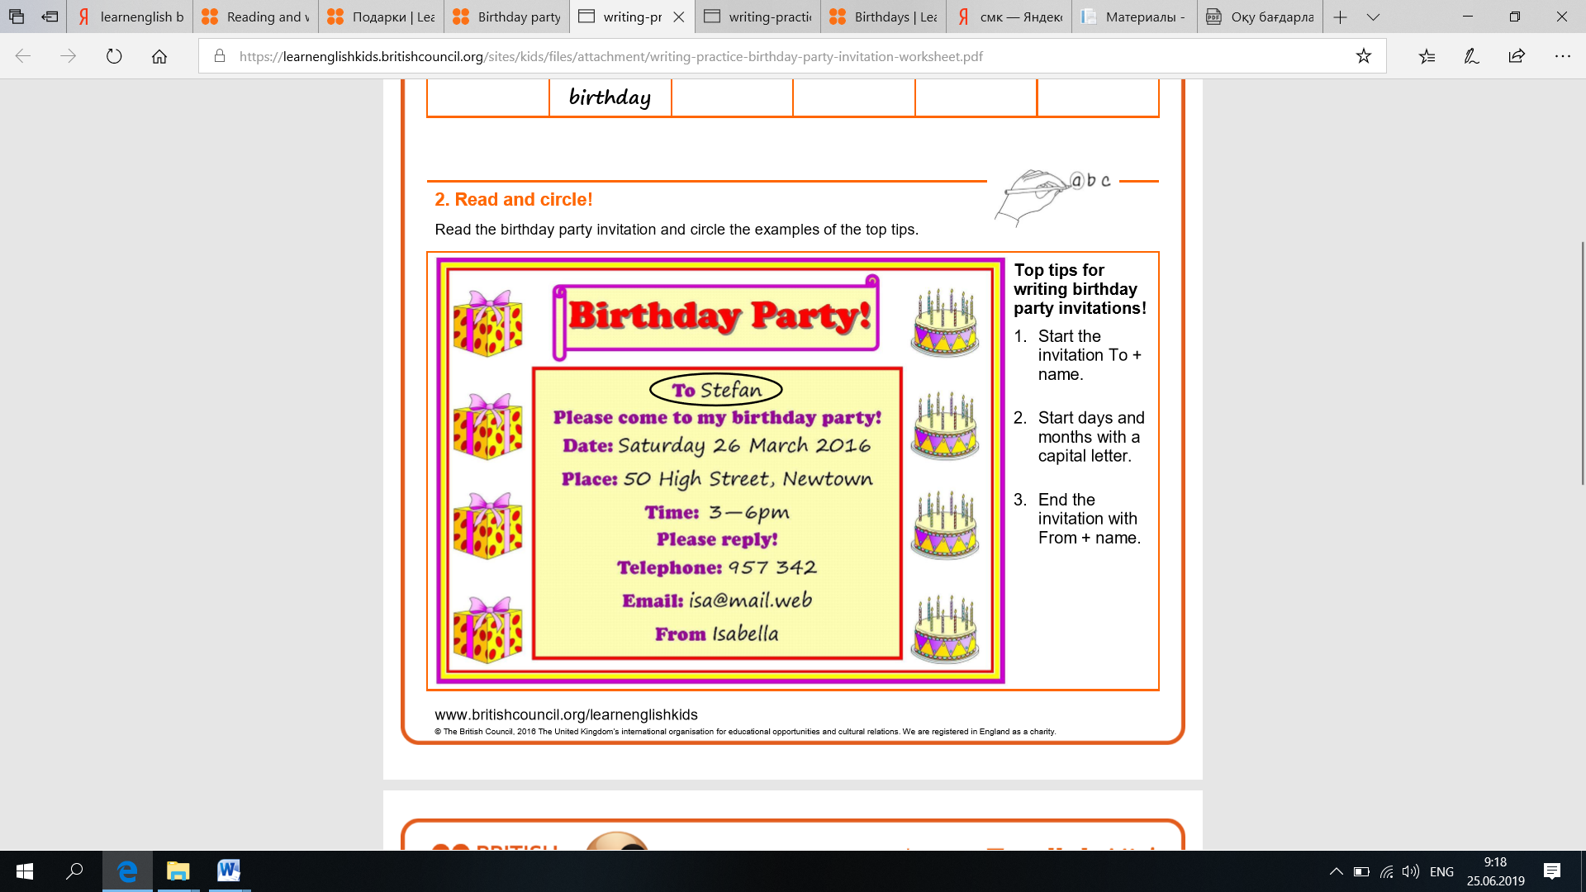  Students are given worksheets with a birthday invitation card. Students read, note the key points, memorize.  Feedback: students work in pairs, discuss and circle top tips to write the birthday invitation.  Error correction: teacher listens to students’ answers and use gestures, prompts to correct students’ clips. L1 using is possible  Differentiation by support.  Writing stage (15 min.)  - First Writing (5 min).  Fill it in! Write the missing words in the sentences.  Students cover tips and try to do the task by themselves.  a. To Stefan  b. Please come to my _______________ party!  c. _______________: Saturday 26 March 2016  d. _______________: 50 High Street, Newtown  e. Time: 3–6 _______________  f. Please _______________!  g. _______________: 957 342  h. _______________ Isabella  Feedback: students check the answers in groups first that in the whole class, opening tips  Error correction: is supported by peers/classmates.  Differentiation by support.  - Second Writing (10 min).  Practise writing!  Write an invitation to your party! Think about these questions first: Who is the invitation for? What date is the party? Where is the party? What time is the party?  Students work individually on the Worksheets 2/1  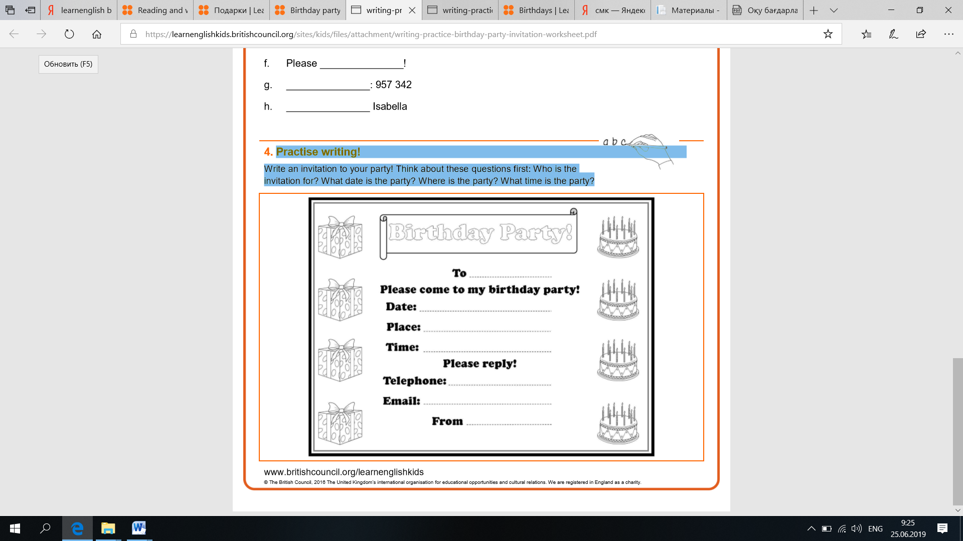  Feedback: Students discuss their answers in pairs before eliciting their ideas in the class. They and teacher use “Finger correction” indicate the mistakes/slips.  Differentiation by support  Post-writing stage (Follow-up) – 5 min.  Students walk around the class and invite their classmates to the birthday party  Error correction: teacher monitors the procedure of ‘Birthday inviting’. |  |  |  |  | Worksheet 2  Worksheets are based on: learnenglishkids.britishcouncil.org/  materials  Pair work  Worksheet 2.1  Individual work
End  (5 min.) | Feedback (5 min.)  Students combine into groups and tell about “My 5 Star” to each other. Teacher coordinates the process of Feedback. Error correction technique is based on ignoring errors that are above the students’ language level.  Reflection (5 min.)  “My five Star”  Students reflect individually  Write 5 things you have learnt today  Error correction: error correction technique is based on ignoring errors.  Differentiation by support. |  |  |  |  | Worksheet 3  Group working strategy
Additional information
Differentiation – how do you plan to give more support? How do you plan to challenge the more able learners? |  |  |  | Assessment – how are you planning to check learners’ learning? |  |  | Health and safety check
Differentiation by support:  Scaffolding techniques such as Activation prior knowledge, Pairing/Grouping the students.  Differentiation by task:  Extra-Task for stronger students (active learning): formulate extended sentences in the process on inviting classmates to the Birthday Party  Learning styles:  Lead-in: “Auction activity - My Birthday invitation ” (visual, group, impulsive)  Pre-writing stage: read and circle (visual, in pairs, impulsive, individual)  Writing stage  First: Fill it in! Write the missing words in the sentences. (group, visual, reflective)  Second: Practise writing! Write an invitation to your party! (individual, group, reflective, auditory)  Post-writing. Follow-up (auditory, group, bodily-kinesthetic, reflective, impulsive, visual)  Feedback/Reflection  “My five Star” (individual, group, reflective, impulsive, visual)  Multiple intelligences:  Lead-in: interpersonal, naturalistic, musical intelligences  Pre-writing: visual, interpersonal  Writing  First: intrapersonal, spatial-visual  Second: spatial-visual, intrapersonal, interpersonal  Post-writing: interpersonal, bodily-kinesthetic, linguistic  Feedback/Reflection: intrapersonal, visual, interpersonal, bodily-kinesthetic |  |  |  | Lead-in: “Auction activity - My Birthday invitation”  Error correction techniques: “Peer and self-correction”, “Ignoring errors”, “Finger correction”  Formative assessment task: “Birthday Invitation”  Feedback/Reflection “My five Star” |  |  | “Let’s do it clockwise”:  Moving from one desk to another to check “Birthday Invitation” worksheet.  “Find another peer to share”: students walk around the class and find a peer to share his/her ideas to Feedback “My five Star”
Reflection  Were the lesson objectives/learning objectives realistic?  Did all the learners achieve the lesson objectives/ learning objectives? If not, why?  Did my planned differentiation work well?  Did I stick to timings?  What changes did I make from my plan and why? |  |  |  | Use the space below to reflect on your lesson. Answer the most relevant questions from the box on the left about your lesson.
Summary evaluation

What two things went really well (consider both teaching and learning)?

1:

2:

What two things would have improved the lesson (consider both teaching and learning)?

1:

2:

What have I learned from this lesson about the class or individuals that will inform my next lesson?

