Lesson plan

Unit of a long term plan: Holidays |  |  |  |  |  | School: Komarovka secondary school
Date: |  |  |  |  |  | Teacher name: Anarbek Askar
CLASS: 5 |  |  |  |  |  | Number present: |  | absent:
Lesson title |  |  |  | Holiday activities
Learning objectives(s) that this lesson is contributing to (link to the Subject programme) |  |  |  | 5.S6 communicate meaning clearly at sentence level during, pair, group and whole class exchanges  5.R2 understand with little support specific information and detail in short, simple texts on a limited range of general and curricular topics  5.W3 write with support factual descriptions at text level which describe people, places and objects  5.UE10 use present continuous forms with present and future meaning on a limited range of familiar general and curricular topics
Lesson objectives |  |  |  | All LWBAT:  - find the sentences in Present Continuous in the text with support  - discuss about holiday activities with some support  - write 3-5 sentences about holiday by using given vocabulary  Most LWBAT:  - find the sentences in Present Continuous in the text without support  - write 4-5 sentences about holiday activities using Present Continuous tense with some mistakes  - discuss about holiday activities using Present Continuous with some support  Some LWBAT:  - find the sentences in Present Continuous in the text with no support and prove it  -write 10-12 sentences about their future trip using Present Continuous tense by using appropriate vocabulary without any support  - discuss about holiday activities using Present Continuous without support
Assessment criteria |  |  |  | Apply present continuous tense with present and future meaning in their writing works
Values links |  |  |  | To be organized, patient and leading healthy lifestyle
Cross-curricular links |  |  |  | Geography, Physical Education
Previous learning |  |  |  | Name of some Holidays, some activities related to Holidays
Plan
Planned timings |  |  | Planned activities |  |  |  |  |  | Resources
Start  (3–4 minutes) |  | Lead-in  Books are closed. Teacher tells students to imagine they are going on holiday near the beach for one week. In pairs, they have 2 minutes to make a list of as many things they can think that they will need. After about 2 minutes, the students stop. Each pair tell teacher some of their items. Teacher put their suggestions on the board, explaining any new vocabulary and modelling for pronunciation. Then he shows the video about travelling. |  |  |  |  |  |  | https://bilimland.kz/ru/courses/education-movies/poznavatelnye-filmy/lesson/chudesa-cveta
Middle  30 min |  | Pre-teaching new vocabulary  Students look at the Presentation of the new vocabulary showing by a teacher. Repeat after the teacher, and copy out the new words.  Guided discovery: Free discussion  Draw students’ attention to the examples. Ask students to underline the verbs. In a stronger class, ask students to go ahead and do the activity by themselves before checking answers as a class.  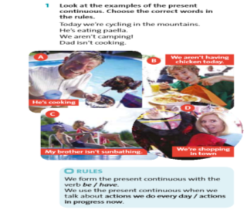  ANSWERS We form the present continuous with the verb be. We use the present continuous when we talk about actions in progress now.  Feedback: Time lines 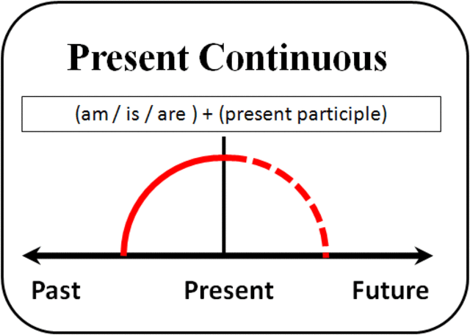  Differentiation: for less able students, go through the rules together and make sure students understand the difference between the present simple and the present continuous tenses.  “Pelmanism” game  The class is divided into pairs and each pair is given a set of picture cards. The students shuffle the cards and spread them out face down on the desk. The students then play a pelmanism game where they take it in turns to turn over picture cards and make sentences in the present continuous about what's happening in the pictures. If the activity on the second card matches with the first card, the student makes a present continuous sentence about the second picture, e.g. The student then keeps the pair of cards and has another turn. This continues until all the cards have been matched. The student with the most cards at the end of the game is the winner.  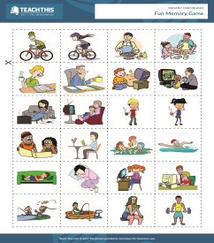  Feedback: Recasting  Differentiation: Dialogue and support; help less able students |  |  |  |  |  |  | PPT “Holiday activities”  “Active teaching and learning”, Nazarbaev Intellectual School Center of Excellence, Astana 2013  English Plus for 5th grade  https://bilimland.kz/ru/courses/english-language/grammar-vocabulary-ru/10-14-let/lesson/the-present-continuous-tense  https://www.teach-this.com/grammar-activities-worksheets/present-continuous
End  5 min | OREO Method of Persuasive Writing  O.R.E.O.  When you are writing about your opinion on any issue, the O.R.E.O. method is a good way to organize your thoughts.  "O" is for Opinion  O (paragraph one) Present the issue which includes the topic and opinion about the topic. A good hook can be a statistic, interesting fact, or quote.  "R" is for Reasons  R (paragraphs two, three, and four) Each paragraph should include one main idea stating reasons for their opinion.  "E" is for Explanation  E (paragraphs two, three, and four) Each paragraph should include convincing evidence or examples that support the reasons. Elaborate!  "O" is for Opinion (again...)  O (paragraph five) The last paragraph includes a restatement of the opinion. Use a call to action and/or suggest what the readers should do  
Additional information
Differentiation – how do you plan to give more support? How do you plan to challenge the more able learners? |  |  |  |  | Assessment – how are you planning to check learners’ learning? |  |  |  |  | Health and safety check
Differentiation by support for “Images Activity”  By task (different types of questions to the weaker and stronger pupils). For FAT: “Images Activity” teacher differentiates the less able students by task, giving worksheets with examples to less able students.  Multiple Intelligence by Gardner:  - Visual (warming-up, presentation)  - Linguistic (reading and discussing about the text)  - Logical/mathematical (pelmanism game)  - Interpersonal and Intrapersonal (think-pair-share) |  |  |  |  | On “Think-Pair-Share” activity teacher corrects learners mistakes using “Reformulating”.  In “Free discussion” teacher uses “Time lines”. Teacher can draw a time line on the board to show learners the relationship between the use of a verb tense and the time or aspect.  With “Fun Memory Game” teacher corrects the mistakes using “Recasting”  For FAT: “Images Activity” teacher gives feedback correcting the learners' mistakes by writing the correct word(s) on the learners' work.  For reflection of the lesson teacher uses “OREO Method of Persuasive Writing” |  |  |  |  | Using active activities.
Reflection  Were the lesson objectives/learning objectives realistic?  Did all the learners achieve the lesson objectives/ learning objectives? If not, why?  Did my planned differentiation work well?  Did I stick to timings?  What changes did I make from my plan and why? |  |  |  |  |  |  | Use the space below to reflect on your lesson. Answer the most relevant questions from the box on the left about your lesson.
Summary evaluation

What two things went really well (consider both teaching and learning)?

1:

2:

What two things would have improved the lesson (consider both teaching and learning)?

1:

2:

What have I learned from this lesson about the class or individuals that will inform my next lesson?

