Unit of a long term plan |  |  | School: School-Kindergarden #26
Date: 2 term |  |  | Teacher’s name: Dina Alibekova
CLASS: 5 |  |  | Number present: 12 |  |  | absent: 12
Lesson title  Unit “Values” |  |  |  |  | Describing appearance
Learning objectives(s) that this lesson is contributing to (link to the Subject programme) |  |  |  |  | 5.S7 use appropriate subject-specific vocabulary and syntax to talk about a limited range of general topics  5.C9 use imagination to express thoughts, ideas, experiences and feelings  5.S6 communicate meaning clearly at sentence level during, pair, group and whole class exchanges  5.W1 plan, write, edit and proofread work at text level with support on a limited range of general and curricular topics
Lesson objobjectives |  |  |  |  | By the end of the lesson:  All LWAT  - describe a person with 7-8 sentences using specific vocabulary with the help of stronger Ls, some mistakes are allowed  -write description of a person creatively in groups using specific vocabulary with 80% accuracy  Most of LWAT  - tell 7-8 sentences correctly using specific vocabulary with the help of teacher  - create a poster of “Missing child” using specific vocabulary with the help of teacher and stronger learners with 80% accuracy  Some of LWAT correct other LL’s sentences orally and written independently or with the help of the teacher
Assessment criteria |  |  |  |  | to write description of a person using new vocabulary
Values links |  |  |  |  | respect and tolerance to other people’s appearances
Cross-curricular links |  |  |  |  | social-studies
Previous learning |  |  |  |  | words on topic Colours, Parts of the body, Clothes
Plan
Planned timings |  |  |  | Planned activities |  |  | Resources
Start  4min | Lead-in – Vocabulary game to activate their prior knowledge on topics Colours, Clothes, Parts of body  Ask the learners to sit in a circle, with a T sitting in the middle.  Say the sentences “Someone who is wearing shirt...”  -Smn who has blonde hair…  -smn who is wearing skirt …  While all the shirts wearer swap places, take a seat in the circle, meaning one learner is left in the middle.  This learner gives the instruction for who swaps places next, and the game continues.  Questioning  Did we talk about clothes?  Did we talk about parts of body?  Did we talk about height?  Ls should guess the name of the topic. |  |  |  |  |  | https://esol.britishcouncil.org/content/learners/grammar-and-vocabulary
Middle  5 min  4 min  3 min  5 min  8 min  5min  5 min | Pre-writing  Introducing new vocabulary  Group work (3 groups of 4) differentiation by support  1.Complete the mind map Think-pair-share (individually, in pairs, in groups)  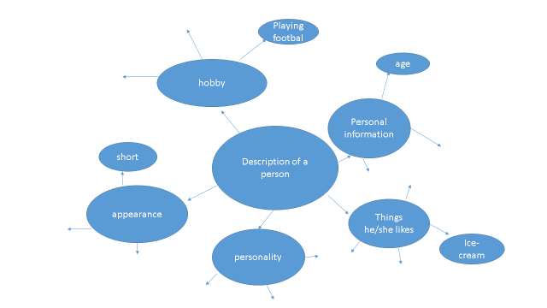  Add your own examples of vocabulary to these categories  Introducing new vocabulary, prediction, matching  Look at new words and try to guess in groups meaning of these words in L1  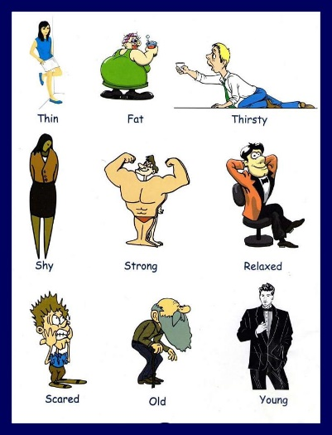  Questions for HOTS (Bloom’s Taxonomy)  Which of these adjectives are negative? Which ones are positive?  Give an example of situation you were brave, rude, nervous…  4. Jumbled up sentences  Make up sentences from the cut words and name the categories  Mary is 7 years old  she has got blonde hair  she is young  she kind looks  she likes reading  she isn’t tall  she has got blue eyes  Drilling new vocabulary and Practicing speaking  with peer-assessment  Wagon Wheel (differentiation by support)  Make inner (strong ss) and out circle (weaker ss), give the strong ss pictures with different people’s appearance, ss move clockwise and describe people, strong ss can correct or prompt weaker ss sentences  Teacher monitors the process (scaffolding by support)  Feedback: peer correction  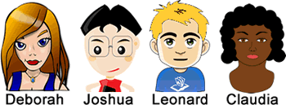  Drafting  Formative assessment task  While writing (still in groups of 4) scaffolding  Step 1 Write a description of the thief  Task. Write a description of  a lost child to the police  to make a “Missing child” poster  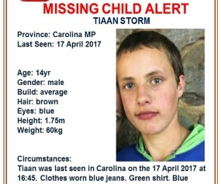  Descriptors  1.Write no less than 6 sentences about child’s appearance  2. Use grammar chunks “has got…” correctly  3. Use no less than 3 words of the new vocabulary  Editing Rotate your writing work and check drafts  Publishing  -Create and decorate “Missing child” poster  -stick to the wall  Criteria-based assessment:  Evaluate posters  - by content (if the description is full or not)  - by creativity  - by accuracy  -Ss should walk around and assess other Ss’ posters |  |  |  |  |  | https://www.google.ru/search
End  3 min | Reflection  2 roses 1 thorn technique  -write 2 points you achieve on the lesson  -1 point you haven’t understood
Additional information
Differentiation – how do you plan to give more support? How do you plan to challenge the more able learners? |  | Assessment – how are you planning to check learners’ learning?  peer-assessment  self-assessment  criteria-based assessment |  |  |  |  | Health and safety check
think-pair-share, support by visuals, graphic organizer (scaffolding learning tool ) |  | peer-assessment  self-assessment  criteria-based assessment  formative assessment task  Feedback: peer error correction, ignoring, finger correction |  |  |  |  | Lead-in,  Wagon wheel
Reflection  Were the lesson objectives/learning objectives realistic?  Did all the learners achieve the lesson objectives/ learning objectives? If not, why?  Did my planned differentiation work well?  Did I stick to timings?  What changes did I make from my plan and why? |  | Use the space below to reflect on your lesson. Answer the most relevant questions from the box on the left about your lesson.
Summary evaluation

What two things went really well (consider both teaching and learning)?

1:

2:

What two things would have improved the lesson (consider both teaching and learning)?

1:

2:

What have I learned from this lesson about the class or individuals that will inform my next lesson?

